Hi {Name}

Here is the link for tomorrow’s certification exam. Please wait to log in, otherwise you will see a notice saying, “Exam session is not available”.
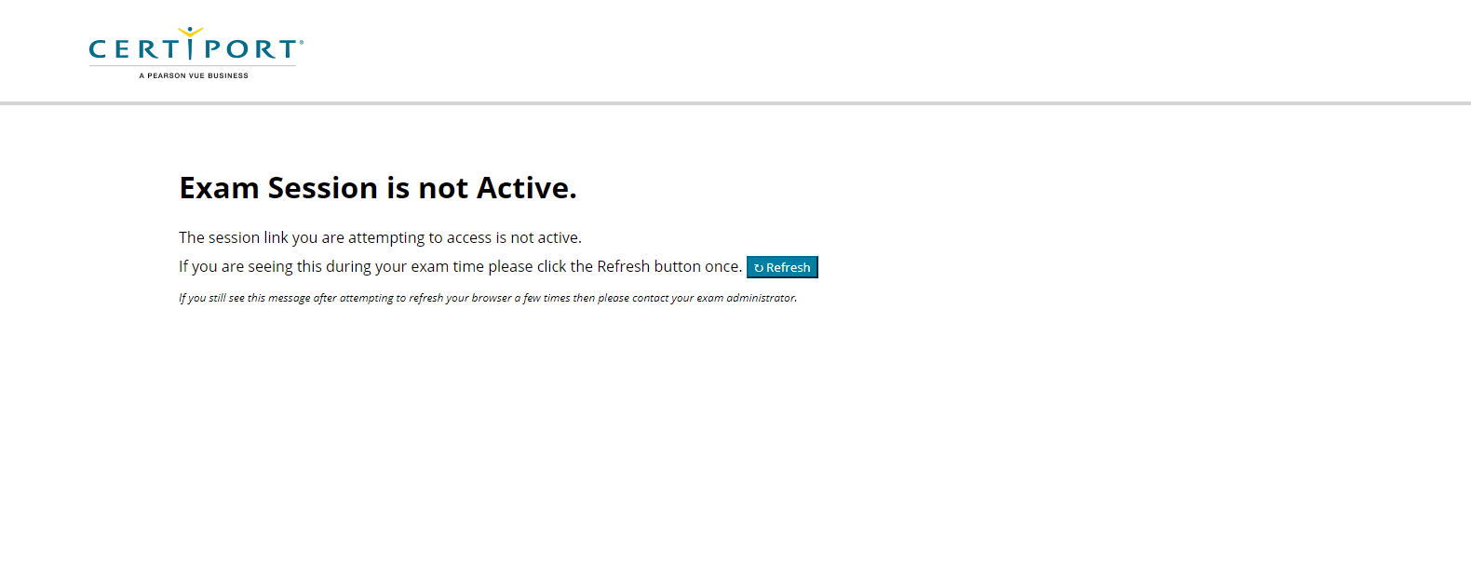
I have sent you an email for a Teams Meeting Video Conference Call. This call is scheduled for 15 minutes prior to the exam. In this meeting I will give you a quick rundown on what the process looks like.

I have also included the Microsoft Office Exam Instructions in a pdf file to this email. You will also see this prior to your exam – some people like to read it ahead of time, but it is not mandatory.

In case you need it again, here is the Test Candidate Guide. It is best practice to have everyone in your home be off the internet so that you have adequate bandwidth, ensuring your best possible success!
Below you will find your virtual URL for Certiport Exams from Home testing on:

Date: Day Month, Year
Time: 10:00 am Time Zone

Please use the following steps to access the exam with your personal URL below:
Testing URL link: https://examsfromhome.certiport.com/join.html?.......
This link is not active until the exactly, 10:00am PST.

Opening the virtual lab in a web browser
- Please copy and paste the above URL into the preferred, Chrome, browser. Most browsers will work, but according to Certiport, Chrome is preferred.
- Press enter to activate the link in the browser.
  - If you are early, the screen will say “exam session is not available”
  - If active, the screen will have the Compass Login screen up.
Logging into Compass
Note: you see the Notepad with directions in the virtual session, you may use this to communicate with your proctor, or minimize it if no communication is needed.

Enter your username and password in the Compass login screen
  - You will see YOUR SCHOOL in the top left-hand corner of the login screen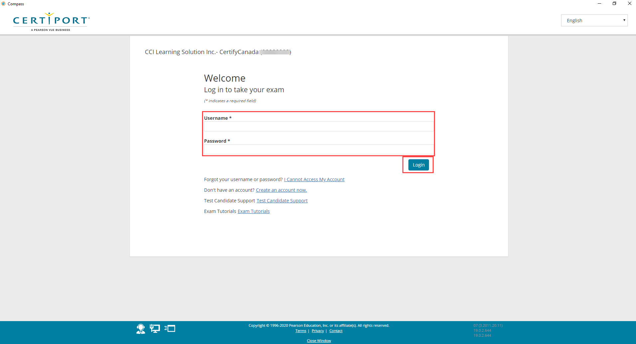

- The default is No to Exam Group and No to Voucher. Click Next

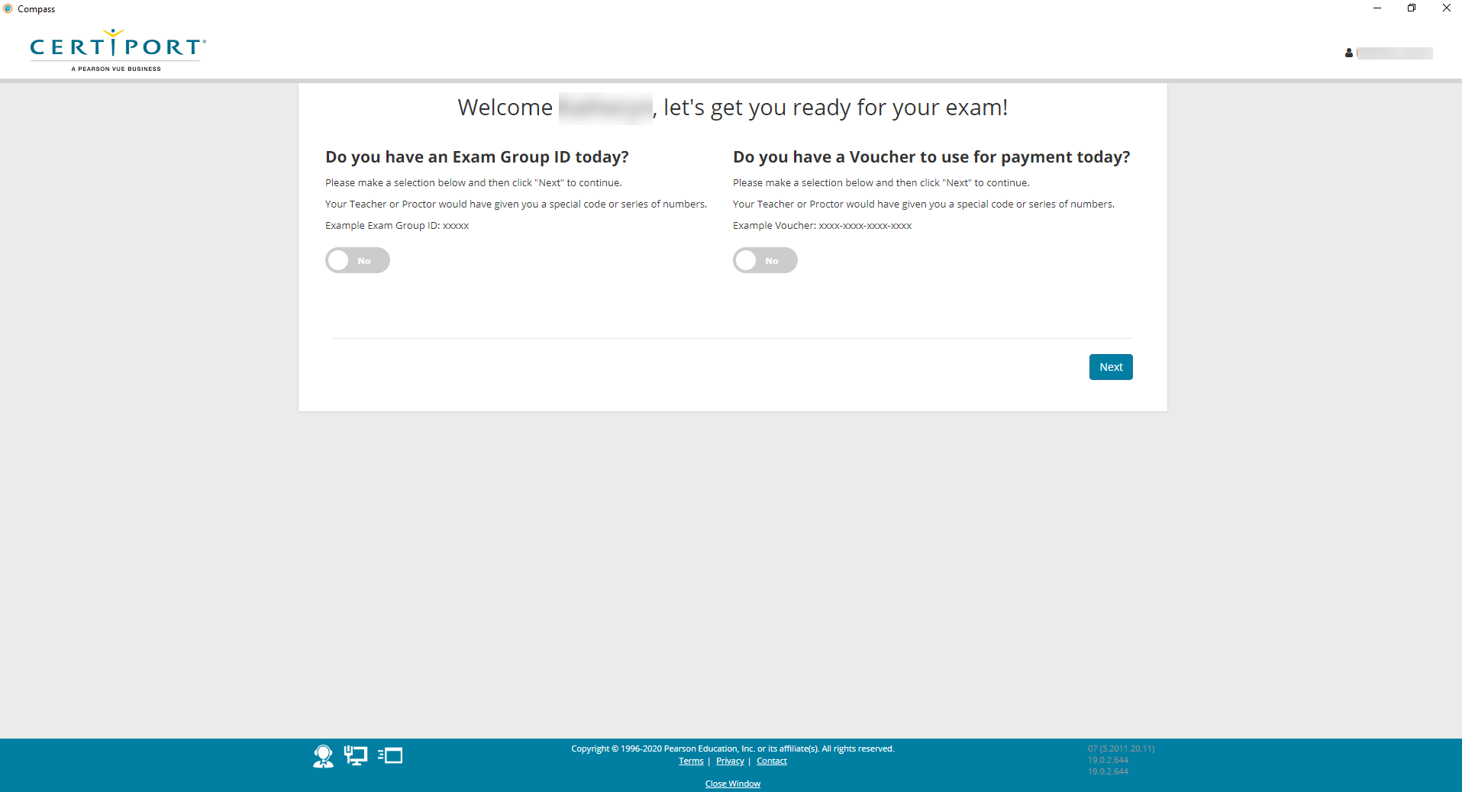
- Select your exam e.g.: Word Core
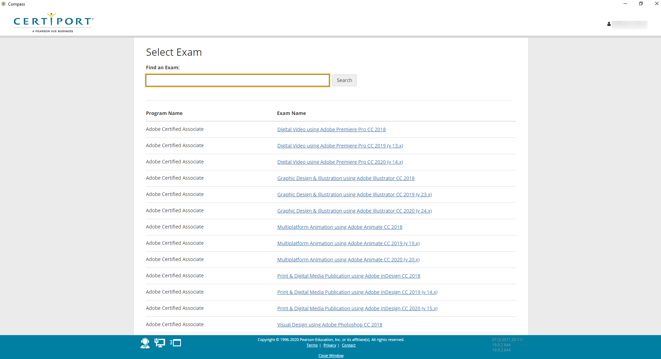
- Sign the Non-Disclosure Agreement If you have not filled out the Microsoft agreement, you will need to do that here- you will be prompted.
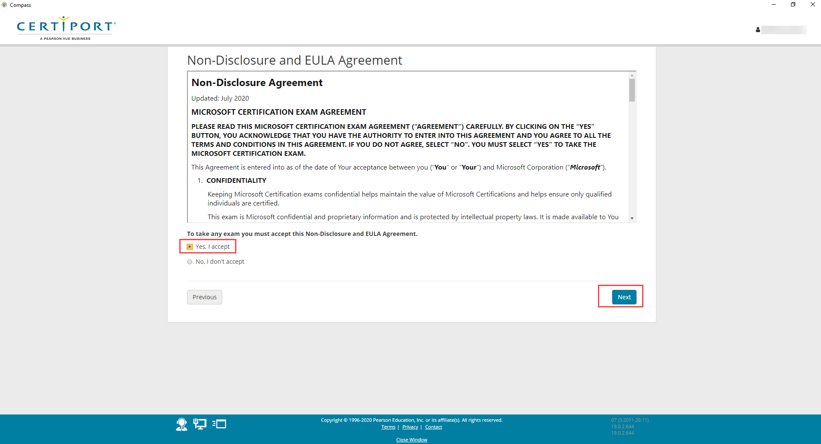

- The proctor will verify and Unlock your exam
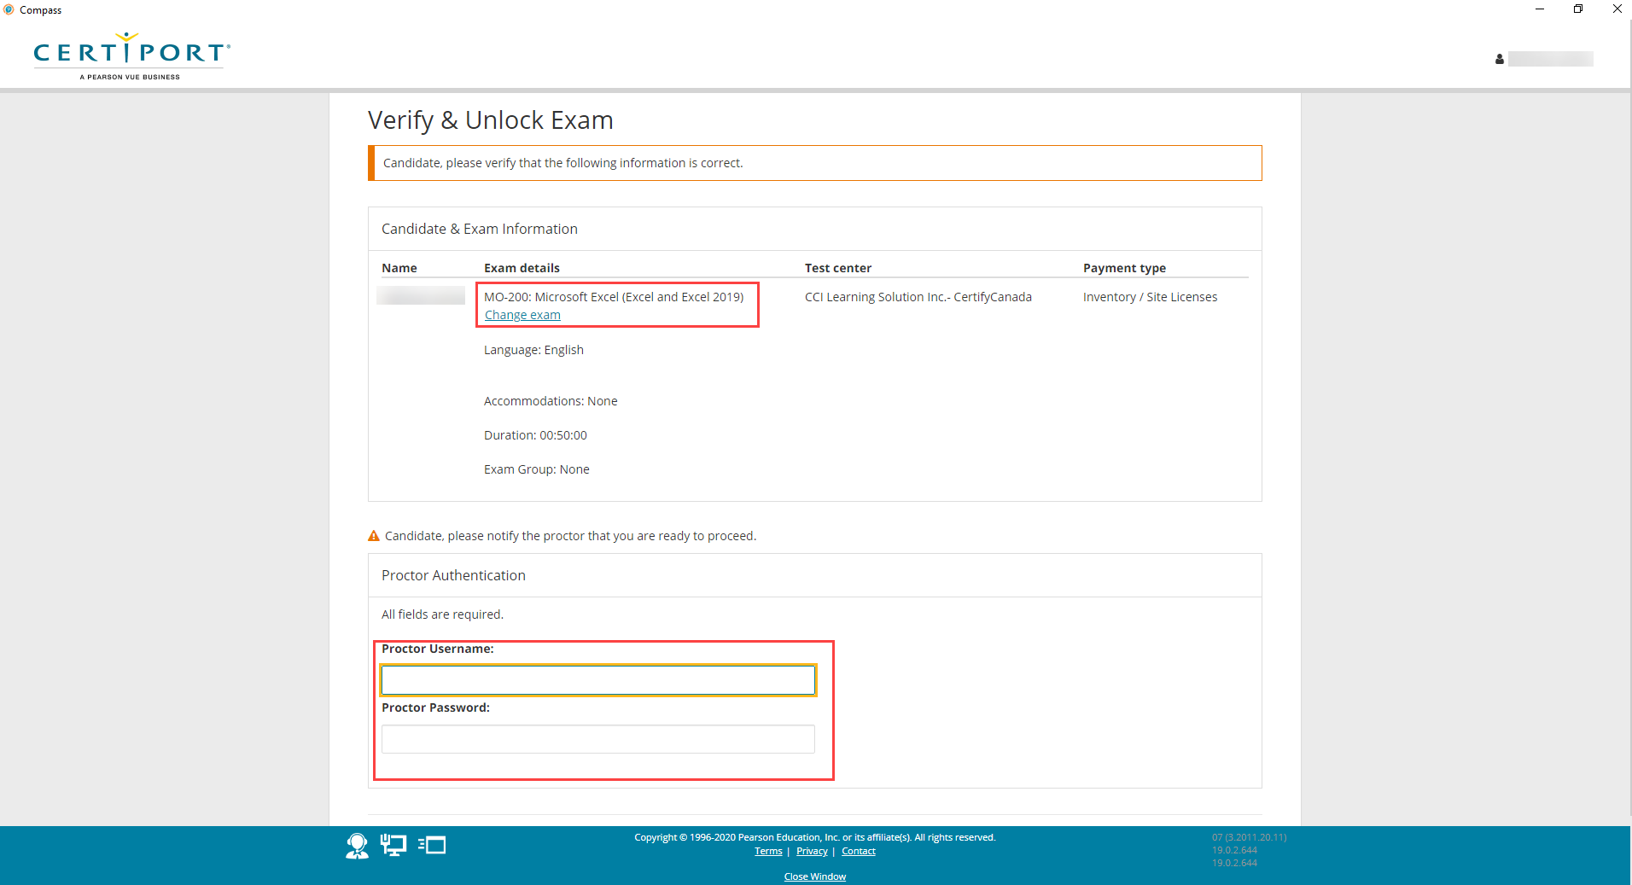
Proctor controls mouse and enters info to unlock the exam
- On the next screen, the proctor username and password. This means the proctor will be taking over your mouse and entering in the credentials.
- The proctor controls your screen for the prechecks.
- Once the exam is unlocked you will be able to read through the tutorial instructions. You will have 5 minutes. The Exam Tutorial instructions are included in this email.
- When ready click start exam.

During the exam
- In the left-hand corner, you will have a two select options. 1) Review Question and 2) Leave Comment.
  - You can select both options on any given question.
    - Review Question: at the end of the exam you will be given the option to go back and review the questions you marked. After reviewing the question, be sure to DESELECT the review button at the top otherwise the system will keep bringing you back to the question to review it.
    - Leave a Comment: After reviewing your answers, the system will allot you 10 minutes to leave comments. Each question you select to leave a comment the system will take you back to that question where you can put comments in a text box. When finished commenting please DESELECT the comment box. Feel free to give your honest opinion. The more feedback we get, the better we can improve the questioning language.

EXAM results
You will see your score after submitting your exam. The Compass system will close and reopen your Certiport account. Here you will see your exam result. You can NOT print in a virtual window. After exiting your exam, you can print your score report or certificate by logging back into www.certiport.com and choosing My Transcript. It can take up to 30 minutes for your score to post.

If you have questions, feel free to contact me.

See you tomorrow!

